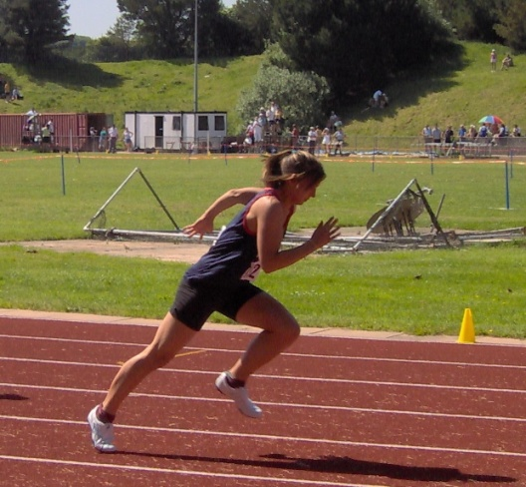

A free e-magazine for speed coaches established in 2006
Available to anyone from tonylett1@gmail.com
UKA Level 4 Development coach for Speed and Physical preparation

ISSUE 85 MARCH 2014
What a month this has been, when a few of the schedules went out the window as there was no chance of training on the sand dunes in an 80mph wind, and on another occasion it was so bad that the ‘all weather’ track was closed. Still, this gave us the opportunity to go over plans with some of the athletes regarding their holidays, exams, BUCS etc, and with the latter coming so early in the year it makes sense to use the ‘short to long’ approach.
A question that arose out of last months issue was why I said the bench press was not suitable for under 16’s. This is my personal rule of thumb and not written in stone. From my experience I have found that up to about the age of fifteen, most children have difficulty balancing a 7 foot long 20kg bar and consequently make a mess of doing the exercise, with the added risk of injury because of this. There are so many other exercises to do without attempting the bench press. I recall being next to the holding pen for the under 15 girls 200m at ESAA, when two competitors asked my 13 year old athlete; ‘what’s your bench’? She thought they were talking about a piece of trendy clothing!
SHORT TO LONG
The past month we moved our speed distance up to 60m, which was fine, but when it came to the 30 second run that we have been doing at the end of each month during winter to give a rough assessment of the effect of their training; most of them failed to progress and I took this to mean it was time to start bringing in some special speed or speed endurance training on a gradual increasing scale, so we shall see if this is having the desired affect.
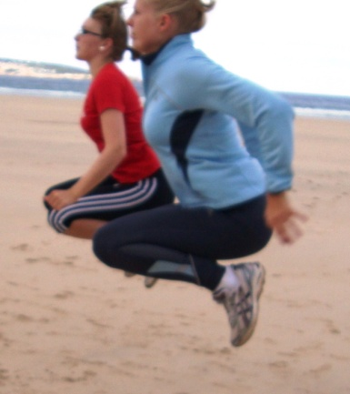
CYCLIC TESTING
I have come across two cyclic tests that supposedly project the athlete’s potential 100m time from their strength.
Time it takes for 50 tuck jump skips. The concept is that a reduced ground contact time will indicate a potential 100m time but the formula for working it out is quite complex, so some of the squad are doing the test several times over the next 8 weeks, then hopefully we can graph the results. (the tuck jump provides a parameter for equality, only the skipping rope is missing from the photo)
TRIPLE AND QUINTUPLE JUMPS
I first published this in November 2007 but cannot locate the results of any tests. Both are done from a standing start. The five jumps should be about 70% greater than the three jumps. The figures quoted in ‘Sprints and Relays’ are
100m time triple jump quintuple jump
10.6/10.4 sec 9.00/9.50m 15.5/16.20m
10.2/10.0 sec 10.00/10.50m 17.0/17.90m
By extension onto a graph this comes to: The rest is up to you!
10.6
11.0
11.4
11.8
12.2
12.6
13.0
3.0 | 4.0 | 5.0 | 6.0 | 7.0 | 8.0 | 9.0 | 10.0 | 11.0 | 12.0 | 13.0 | 14.0 | 15.0 | 15.0 | 16.0 | 17.0 | 18.0

TRIPLE EXTENSION
Triple extension is the movement of three joints in unison, from an acute degree to their fully extended position, namely the ankle, knee and hip. It can be see in throwers, jumpers, hurdlers and sprinters, especially in the first seven strides of the race. Logic therefore indicates that if the ability to triple extend is needed to perform an event to the best of an athletes ability, then they should practice it in training so that it becomes a natural movement; while developing the muscles and joints that are involved, to grow accustomed to what is required of them. This will not only enhance performance but will reduce the risk of injury.
Not all exercises that achieve a triple extension need a gym or the use of weights, though the addition of a resistance can add to the strength of the muscles and the reaction of the fast twitch fibres.
The coach should watch for technique that should show a fully stretched ankle, straight leg with the body aligned through the erector spinea, because if it is not right at this stage, any faults will carry through into other exercises
Equipment free
- Lets’ start with a simple Squat Jump, going down to touch the ground with the fingers before springing up to perfect the extension of the ankles.
- Now develop this into a Rocket Jump (fig 1) with the hands reaching as high up above the head, helping to drive the body upwards off the ground with a triple extension.
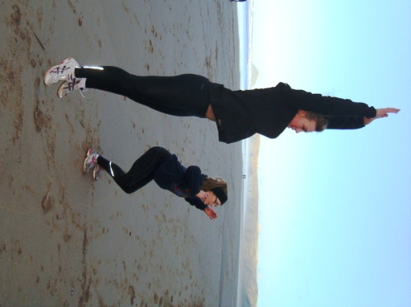
- Vertical bounds with a full extension of the drive leg helped by upward driving arms, can be done in the warm up with four progressive bounds followed immediately by a 30m run, then repeat; making total distance of about 80m.
- Falling starts with a high knee poised parallel to the ground at the start
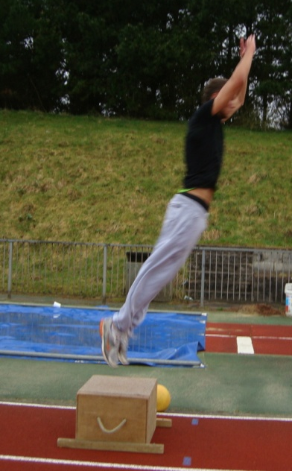
.Medicine Ball
- Rocket jump with med ball held between both hands
- Rocket jump with a bucket toss starts with a medicine ball held down between the legs in extended arms. As the jump starts the arms swing up in an arc and toss the ball as high up in the air as possible.
- A variety of this can be to toss it overhead while jumping,
- Or toss the ball forwards, always remember that the emphasis is on the triple extension.
- The vertical chest throw also starts from a squat position,
- Move from a leaning forward squat jump to include a chest throw while facing a high jump mat This will cushion the landing and reduce the fear of injury while encouraging a greater forward lean. Incidentally, powerful chest throws also help to develop the upper body that will enhance sprinters ability at the start.

Box jumping
Triple extension box jumps can be done with and without a medicine ball, either from the bound off the box or from a squat landing.
- The box jump with squat landing and throw,
- The box jump up and throw. When coming off the box (fig 2)
- These jumps can also incorporate a med ball toss
Using weights
- The Power clean with a weighted bar is more suitable to older athletes, having the advantage of starting with a triple extension as the bar is brought upwards from below the knees, then again, after the transition to the shoulder position, the body can sink back to triple bend position before everything can extend upwards once again for a double whammy.
- Any athlete over say, fourteen years old, will be able to do the dumbbell rocket jump; holding a dumbbell to the floor in one hand (fig 3) before leaping skywards helped by the impetus of the dumbbell being heaved swiftly above the head. (fig 4)
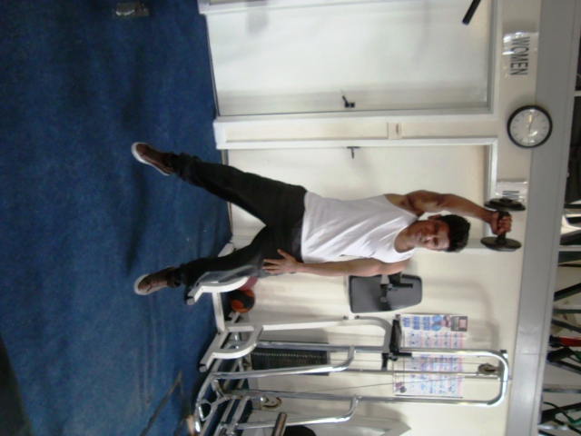
. 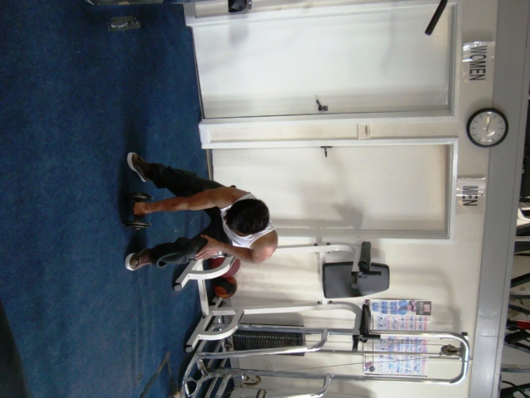

fig 3 fig 4

Frequency
Performing triple extensions is not seasonal, therefore it can be done intermittently throughout the year, with the number of reps being dictated by time available, reaching perfection, avoiding boredom and equipment to hand; with a guide of between twenty and fifty reps. You could even set up a circuit of triple extension exercises, with change over control being by a set time or whistle. Remember, coaching is not always a question of doing the extraordinary but more about doing the ordinary, extraordinary.

NEXT MONTH: Starting and accelerating

