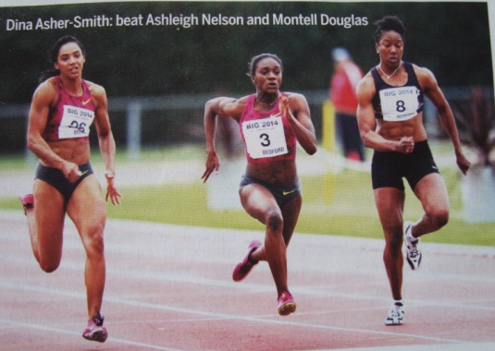

A free e-magazine for speed coaches established in 2006
Available to anyone from tonylett1@gmail.com
UKA Level 4 Development coach for Speed, Strength and Physical preparation

ISSUE 89 JULY 2014

HIP FLEXORS
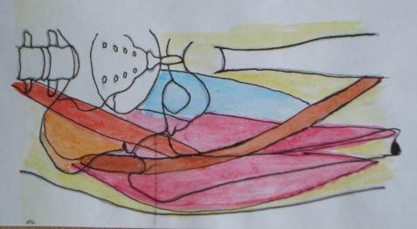
These are the five muscles that join the hip to the leg and react with the extensors to move the leg through an angle when running, while at the same time helping to hold the hips in place. If the hips drop(see picture above from AW) due to weakness of the flexors, amongst other muscles, leg movement is restricted, resulting in longer ground contact time (GCT) and reduced ground reaction force (GRF) simply because their extension and pre tensioning is restricted. (Maybe this is why some athletes fail to reproduce their pb form).The hip flexors themselves, shorted in order to apply maximum force, therefore mobility and strengthening of these muscles will have an effect, no matter how small, on overall performance.
Psoas major

Iliacus

Tensor Faciae latae

Sartorious

Rectus femorus

The five flexor muscles (and remember, they do not act in isolation) are; Psoas Major which runs down from the spine, starting high up behind the rib cage, through the inner hip and attaches to the top of the thigh bone.. The Iliacus lines the inside of the hip, and I cannot recall a specific exercise for it, except perhaps childbirth!
Together, these two muscles form the Iliopsoas group.
The Tensor fasciae latae has its origins on the outside of the hip under the obliques, coming down across the upper thigh to terminate in the lower adductors.
The Rectus Femorus is well known as a major muscle in the quadriceps, as is the Sartorious, a stabilizer muscle which passes the inside of the knee and joins the tibia on front of the knee. :
.
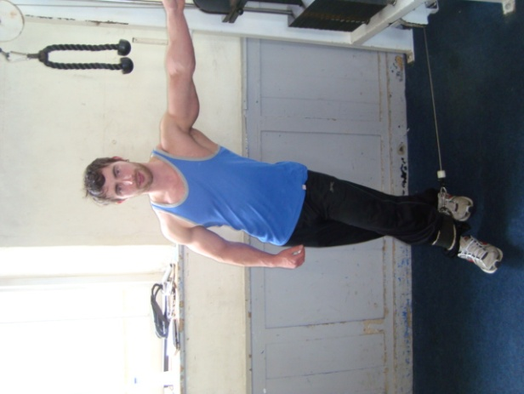
Bum (1972) and Hay (1978) both stated that at takeoff the hip should be extended through as great a range as possible, and that failure to complete extension is one of the most common
faults in sprinting. Kunz and Kaufmann (1981), however, found that world-class sprinters had less upper leg extension at takeoff than did a group of decathletes when performing
a maximal sprint. So, take your pick!
Exercises
The cable machine or resistance band, is one of the most versatile for exercising the hip flexors. In each case stand at arms length from the frame and adjust the weights to permit completing the exercises with a straight back
As shown, the adductors are pulling the cable using the Sartorious. Turn around so that the abductors are pulling to engage the Iliacus and tensor faciae latae. Turn your back to the weights and pull the cable forwards to work the Rectus Femorus; the major muscle in the quadriceps group, that will also benefit from inclined crunchies, knee raise, hanging leg raise, dumbbell, barbell, hack and power squats; leg press, leg extensions and lunges.
The iliopsooas which groups the psoas major and iliacus, and tensor faciae latae will also benefit from the inclined ab curls (crunchies) when done with a twist. Exercises that will benefit this are leg/knee raise, declined crunchies, hanging leg raise, cable or resistant band hip abductors Without a declined bench, try laying on your back, putting the feet high up a wall or on a steeplechase barrier, then crunching to touch the shoe laces.

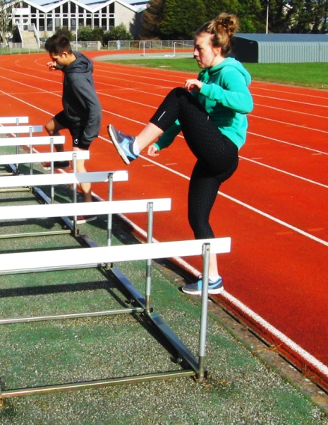
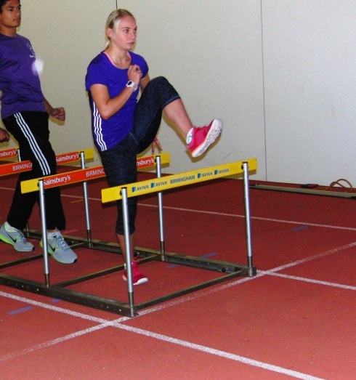
Hurdle drills should be done with as high a knee as possible, but avoid arching the back (right), often caused by the hurdles being too high, or a lack of flexibility or concentration.
X

MOBILITY

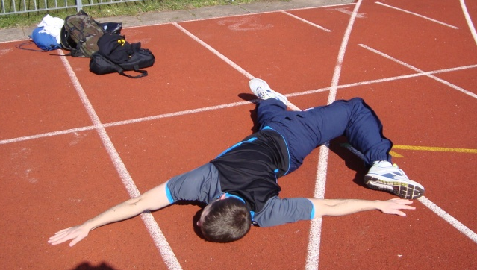
The T stretch should be done with the shoulders in constant contact with the ground when touching left foot to right hand, and visa versa. Three reps of this with a 3-5 second hold can be repeated with the athlete laying on their front

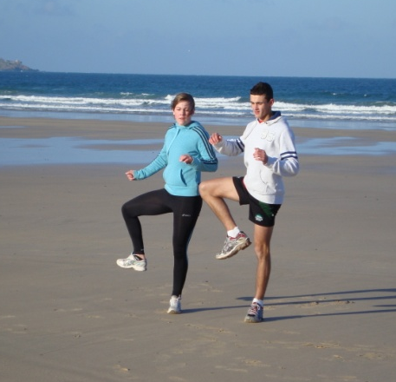
Hip flex skip
Start by walking through the exercise, lifting the knee to waist height before opening it up to the side before returning by the same route; then the other leg.
The next move is to skip while lifting the knee up to the front and return to the ground before repeating the action but this time opening the leg out to the side. On the next skip the same routine is done with the other leg, and so on
STRETCHING
Continuing with some of the ‘less than usual’ stretches, the following work the adductors as well as some of the hip flexors
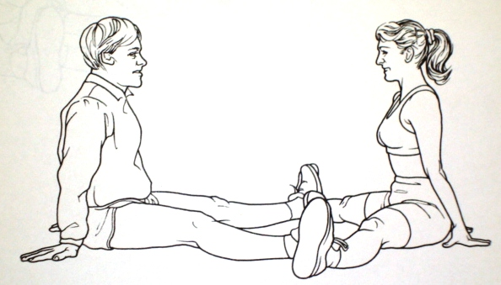

One athlete, the stretcher, gradually applies pressure against the inner ankles of the other, with suitable recovery pauses before applying more pressure for up to3 sets

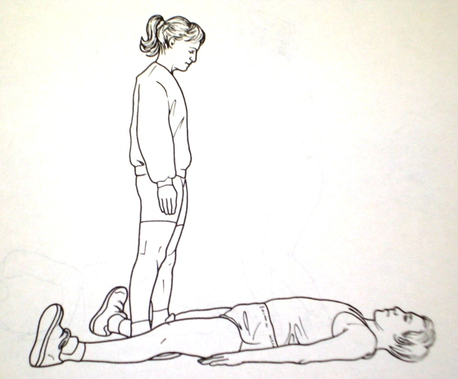
The stretcher starts nearer to the feet, pushing the legs out sideways. As they move up the legs the degree of stretch increases. If you have never done this before, beware of over-stretching.

Psoas stretch
The back must be kept flat on the table by pushing one leg towards the chest, the opposite leg is then pressed down towards the floor to stretch the psoas muscle to its ROM.
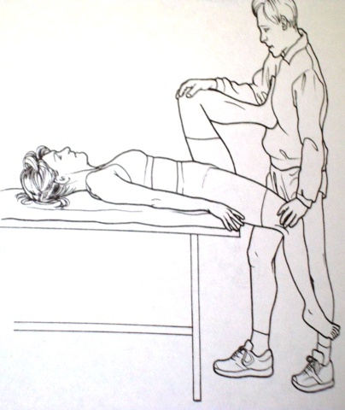
The athlete then tries to lift the knee towards the opposite shoulder against the resistance of the partner for a period of 6 seconds.
Relax for 6 seconds before the partner tries to increase the ROM by pressing down on the knee before the routine is repeated for up to four times.

THIS AND THAT
- At the squad we repeated the ‘speed test’ that we did in Feb and smashed the times by an average of one second. (The test involved running 4x flying 30m with 30m jog back) The amount of drop off in times gave me some idea of who needed more endurance training.
- There are a number of long jumpers currently running some fast 100m times, and in the past the same could be said of Linford Christie and Carl Lewis. In my own squad an U15 boy is now the county L/J champion without any specific event training. The only reasons I can see for this connection are the bounding and plyometrics that we do.
- I’m currently reading THE DIRTIEST RACE IN HISTORY by Richard Moore about Carl Lewis and Ben Johnson, and so far it’s proving interesting
- My mountain climbing exploits raised £1119, thanks to your help

