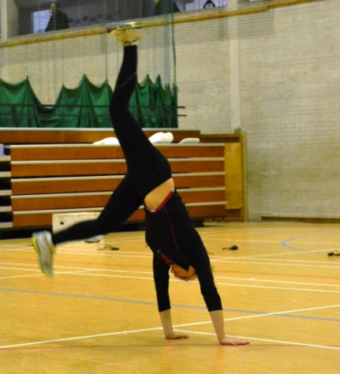

A free e-magazine for speed coaches established in 2006
Available to anyone from tonylett1@gmail.com
UKA Level 4 Development coach for Speed and Physical preparation

ISSUE 83 JANUARY 2014
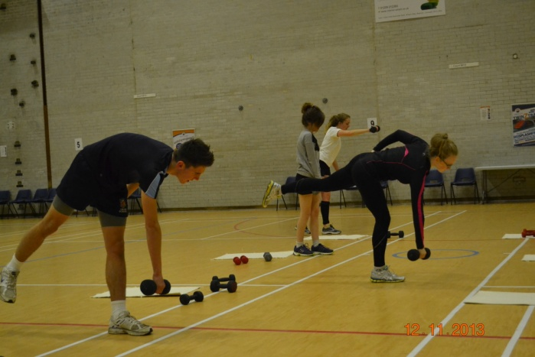
For a good few years I have occasionally included cartwheels into the warm up, as much for the benefits of balance and agility, but more recently the number of athletes capable of doing them has diminished dramatically and I wondered if this was a national trend and if children spend time doing less sporty things or even if PE teachers use Health and Safety as an excuse.
SINGLE LEG EXERCISES
The balance involved with single leg exercises activates the Central Nervous System (CNS) that controls all the muscles, allowing them to react instantly to any imbalance, which is just what we want, rapid reaction of the muscles. In addition it will overload each leg and show up any imbalances in strength
.THE DIVING SWAN or as some call it, THE SINGLE LEG DEAD LIFT.
Starting with the dumbbell held out at arms length (see far athlete), as the dumbbell comes down towards the floor the leg ON THE SAME SIDE (same arm, same leg) swings backwards. It can be done by using opposite arm to leg which makes it easier but less effective. It works the gluteous maximus and hamstrings, the latter more so if the leg is straight (see near athlete). Action should be slow.
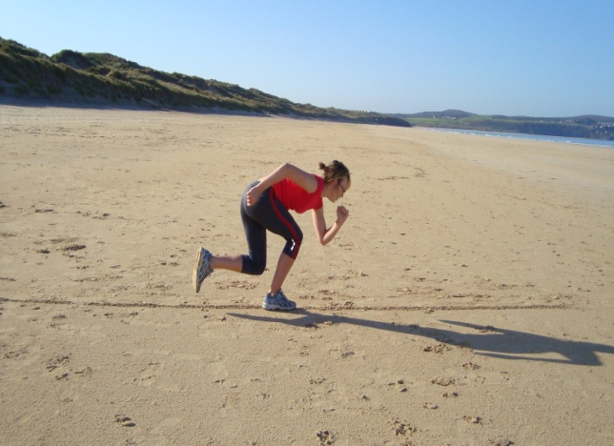
CHICKEN RUN
The athlete takes up the position shown, then with an upward bound they move forward ( Staying on a line sometimes helps) Alternatives: 1) Land on the same foot 2) land on an alternating foot
LATERAL STEP JUMPS
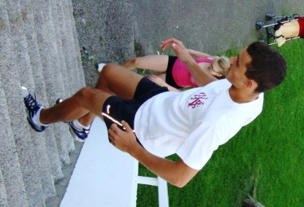
Iv’e covered this one before. Starting with one step, jump laterally up the flight, then advance to two steps etc, obviously doing both legs
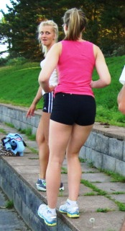
QUAD DIPS
While you are on the steps, why not do these. Pointing the heel down, keeping a straight back, dip the foot down as low as possible without it touching a lower step.

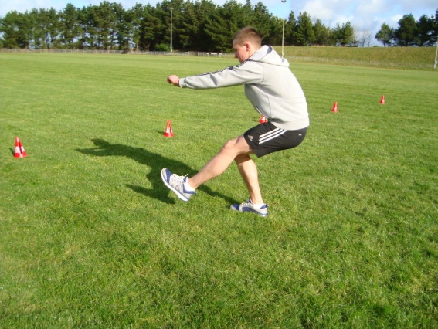
SINGLE LEG SQUAT Squat as low as possible on one leg. If indoors then why not try squatting to just touch a chair with the glutes before lifting.
Alternatives: 1) Turn it into a jump 2) hold a med ball 3) Toss the med ball upwards either from a standing or jumping position

STRETCHING
A couple of stretches from my friend Hans Peter Thumm in Germany, AND National Coach in Tanzania. HAMSTRINGS.
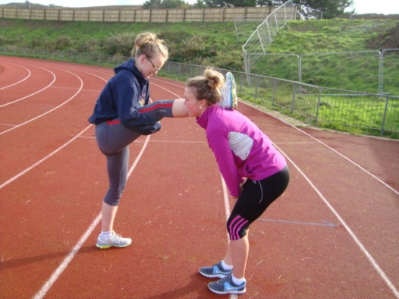
One athlete crouches down while the other places a leg on their shoulder. The squatting athlete rises until told to stop. Hold the stretch for 7-10 seconds. Repeat 3 times before switching legs.

RESEACH HAS SHOWN THAT ANY GAINS FROM STRETCHES HELD LONGER THAN 10 SECONDS DO NOT JUSTFY THE TIME INVOLVED.

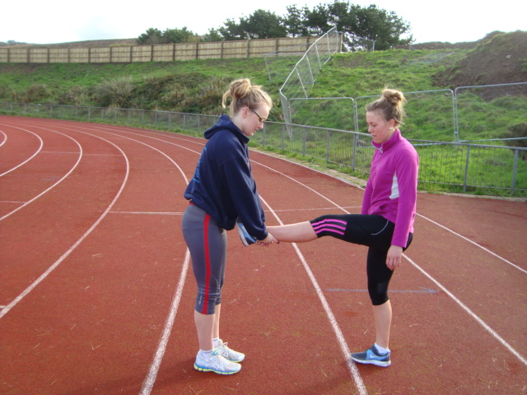
Starting in the position shown, the assistant athlete takes a small step backwards but remains upright, taking the leg with them. The stretching athlete is forced to lean forward as the leg angle increases. Turning the standing leg at an angle will stretch the inner thigh adductors.

QUAD STRETCH Take the lunge position with the rear knee as close to the ground as possible, then lean backwards to put more weight on the rear leg. Easy!

SQUAD UPDATE ON SHORT TO LONG
The speed distance increased to 40m, sometimes with a jog to the far straight for a 70-80m run at 70% before getting back to the start of the next run. Downhill as well as uphill running on the dunes continues.
Strength exercises continue with explosive positive moves and slow negative returns on a 3:1 ratio. This was also applied in the end of the month circuit. Christmas is an inconvenience, but we always wear something festive on the final night, run shunt relays carrying med balls and running over cones.

THE SECOND POWER STRENGTH EXERCISE DESIRABLE FOR SPRINTERS.THE BACK SQUAT
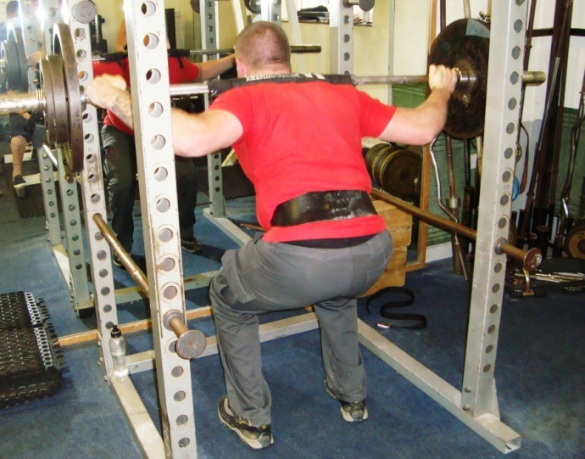
The most popular exercise in the gym, but even this can be done badly, more often by trying to add too much weight, too soon. Take a stance with legs hip width apart, take in a deep breath and tighten the abs and pull the shoulders back (known as ‘blocking’), all of which helps to keep the back straight, along with looking ahead and pushing the bum backwards. The depth of squat is often contentious, where weight lifters will encourage bringing the thigh below horizontal, because that is what is required in their competitions, but I believe that for athletes it is not necessary to go lower than a 90⁰ bend at the knee. To place more emphasis on the long head of the quads (closest to the knee and used extensively when starting), then quarter squats can be used, which obviously means coming down to only a quarter of the normal distance. Muscles involved with his exercise include the quads, hamstrings, gluteous, abdominals, with the abductors and adductors working to a lesser degree, and dependant on the leg position (see Power Squat). You will note that there may be some breathlessness towards the end of each set, because, like running for more than six seconds, the Alactic energy expires and the Lactic system kicks in.
Watch out for lifting the heels and bending forwards at the hips

