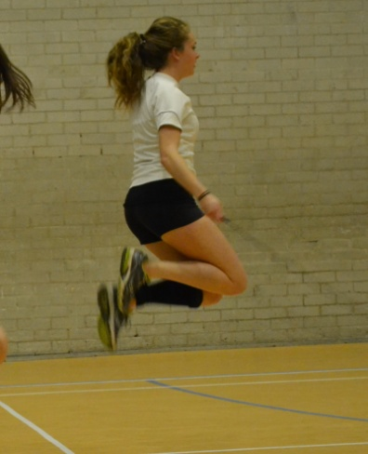

A free e-magazine for speed coaches established in 2006
Available to anyone from tonylett1@gmail.com
UKA Level 4 Development coach for Speed and Physical preparation

ISSUE 84 FEBRUARY 2014
This issue marks the beginning of the 7th year of monthly publication. In truth it began over eight years ago when I was the South West event coach, but then it was not a monthly and only designed to keep regional coaches up to date with what I was doing at specific SW coaching weekends.
Skipping (see Header photograph)
Do not dismiss skipping as a valid exercise as it is a good coordination medium, for bum kicks, tuck jumps, single leg kicking bum kicks (kicking the bum with the same leg you are hopping on, speed skipping to reduce ground contact time, speed endurance skipping where athletes are in pairs-one skips 50 times, then the other, then the first one again; until both athletes have skipped 3 times;- making it a race between pairs of athletes etc .
CORE BLIMEY
We all know the benefits of core stability, so here are a few variable
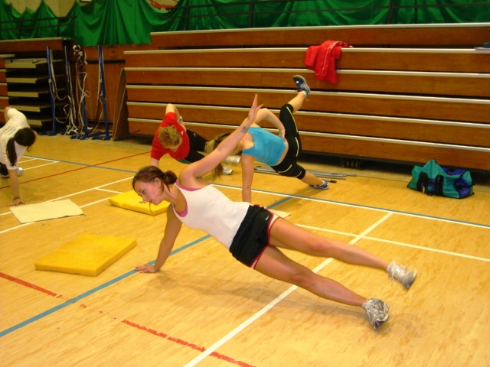
With the side plank try lifting one arm or one leg, or both. Always check for horizontal alignment without the bum going back to form a curve. For added spice, lift and lower a dumbbell laterally or lower a dumbbell to the floor then lift aloft, several times. Excellent for core stability, IT band and abductors
With the standard plank you will get more benefit from the local muscles around each vertebra if you create movement every ten seconds by lifting a leg or an arm, or both, and holding for ten seconds, or lift one leg and bringing it forward towards the elbow, like a dog on a lamppost.
Note the head is above the hands
Lateral ball throws that bounce off the wall are good for the obliques so long as the hips remain facing forward, unlike the 3rd athlete shown.
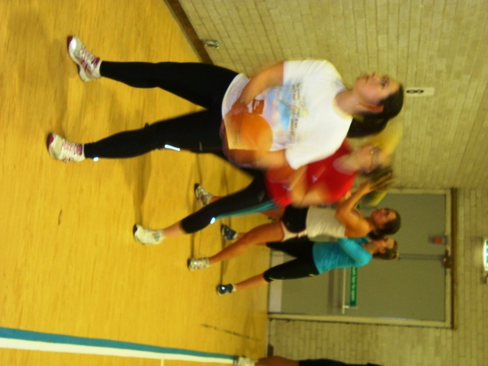
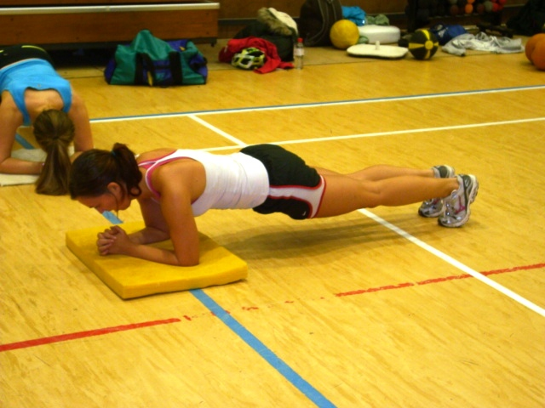

IF ITS GOOD ENOUGH FOR THEM, ITS GOOD ENOUGH FOR US.
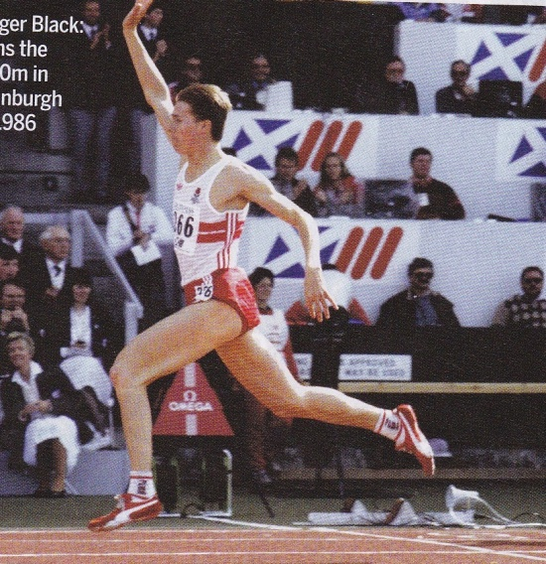
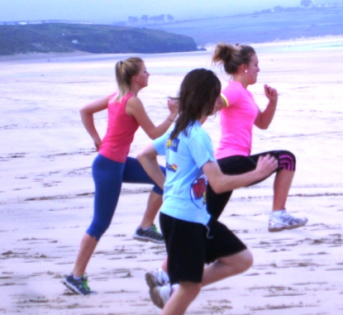
Amantle Montsho & Christine Ohuruogo 2013 World Championships Roger Black 1996 Olympic Silver medal 2013 CAC sprinters

To emphasize the forefoot plant (as shown by the best of international athletes) rather than ‘heel-toe’, we often practice long bounding, with the athletes taking turns to watch each other from the side.
SHORT TO LONG REPORT
As the squad continue with their adaption of this routine the speed element distance has moved up to 50m. coupled with an explanation that being quick at the start is all well and good, and most races will show that at 20-30m there is very little to choose between the runners, which shows that start practice is beneficial, but ultimately the race (over 100m) is won in the last 50m, so if we are to run fast 50’s, lets do it over the latter part of the race. To help us achieve this objective we set up four cones at approx 6-10m intervals prior to the 50m to give defined acceleration points as the controlled speed built up to to the start of the final 50, ran at max speed. They found this better than just trying to calculate their own rates of acceleration which tended to be hit and miss.
CONTINUING WITH GYM WORK-THE BENCH PRESS
The Bench Press
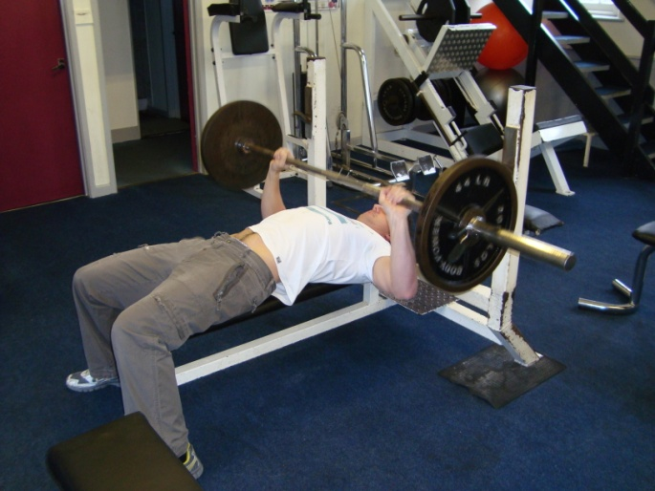
A spotter should be available during early use of this exercise and when getting close to maximal load.
Laying flat on the bench, the bar should be just above the chin. Grasp the bar so that the arms are near to vertical, with angles of 90⁰ at the elbows, and arms to torso, and the load is going through the lower palm directly into the arm rather than trying to bend the wrist which can lead to carpel tunnel syndrome
90⁰
(Olympic bars have guide rings to help achieve a balanced grip)
The feet should be flat on the floor although some people prefer to lift them up onto the bench end, which helps to press the back down onto the bench but builds instability and detracts from lifting maximum weights.
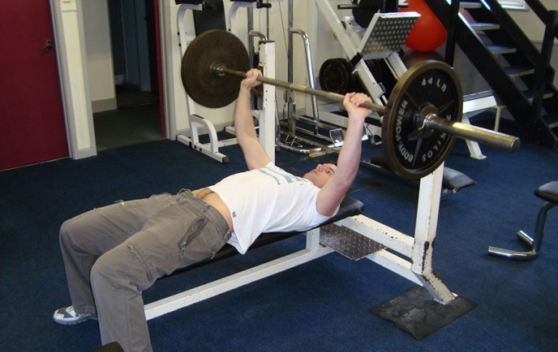
Lift the bar up off the rack, move it forward and lower it to the chest and without bouncing it off the ribs, raise it to an almost straight arm position to keep tension in the muscles
Repeat for the required number of reps.
Safety collars
Beginners should start with an unloaded bar and progress slowly to get good technique, not rushing into the exercise. For general fitness an established athlete will often get the best results by moving up to maximal weight in about 3 sets, then working down with reducing weight.
Sets of 3 reps for max strength and 6-8 reps for endurance strength.
To improve muscle hypertrophy, lower 3 times slower than pressing up, using a weight that is good for about 6 reps.
Using a closer grip on the bar gives an effective triceps and front deltoids workout.
NOT FOR UNDER 16’s
WHY BENCH PRESS WHEN IT IS UNRELATED TO RUNNING?
It is a good all-over body exercise, starting with the chest, arms and shoulders, it also incorporated tensioning the abs and keeping the back in contact with the bench, whilst also putting tension into the leg muscles as the feet press into the ground. The balance aspect motivates the CNS and the end result gives a moral boost to an athlete.

IF YOU HAVE DOUBT ABOUT PERORMING ANY EXERCISES, WHY NOT CONSULT SOMEBODY ELSE OR SHOW YOUR ATHLETES THESE PICTURES

Coaching is not about doing the extraordinary, but about doing the ordinary, extraordinary.

LONG TO SHORT UPDATE

We took advantage of the recent warm weather to do some start practice, filming it at 40 frames/second and played back at 15f/s the athletes can study themselves in action and it gives a good tool on which to built a training emphasis. Add to this the use of the clubs recently acquired electronic timing gates for 10m and 20m splits, the athletes had a good incentive to put in 110%
More of this will be covered in the April issue

READING
Having just finished the Paula Radcliffe book, which I found very interesting and full of information, I am now into Jessica Ennis which is also proving to be good reading, especially on her athlete/coach relationship.

