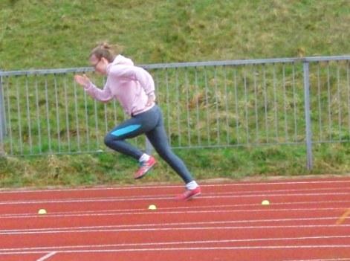

A free e-magazine for speed coaches established in 2006
Available to anyone from tonylett1@gmail.com
UKA Level 4 Development coach for Speed and Physical preparation

ISSUE 86 APRIL 2014
STARTING
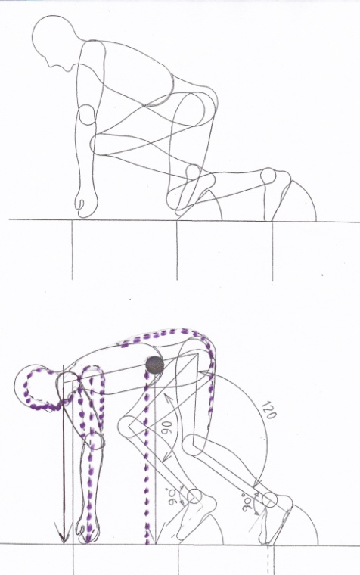
Many moons ago when I was in Loughborough doing my Senior Coach course we were taught starting using the diagram (fig 1) that shows forward lean on the arms and with a suggested focus of 30m up the track. I took the tutor’s word for it, for afterall, what did I know, I was converting from middle/long distance. Since then however I have read literature from coaches with a high level of athletes around the 10 second mark or better, and several things contradict what I was taught, and to me they made common sense. So here we go.
On the word SET it is generally understood that the hips should rise above the line of the head, which is fine, but this is also where things can go wrong, following the misguided concept that they also lean forward, bringing the shoulders ahead of the hands and putting pressure on them. This can easily be checked in practice and made visible to the athlete by using a stick or weighted string to drop down from the shoulders.
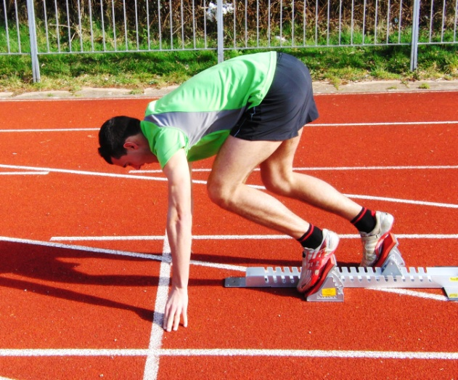
When the gun goes off, it now becomes impossible to instantly drive the arms forward or backward without first lifting them off the ground, and like the middle distance runner, it loses vital fractions of a second. However, by keeping the shoulders above the hands while still raising the hips, places a lot more load (pressure) into the feet, where it should be, next to the ground, allowing the arms to react more quickly.
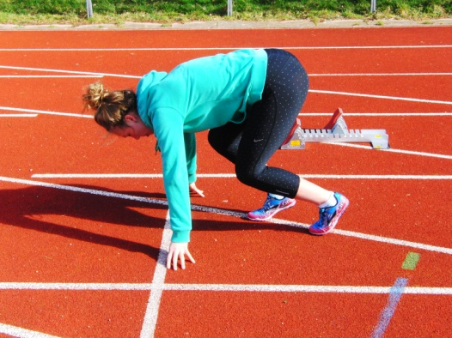
Once this position is established, the coach can now look at the leg angles which may be different from when using the forward lean, and may require moving the block setting back to bring the standard back to 90⁰ and 120⁰
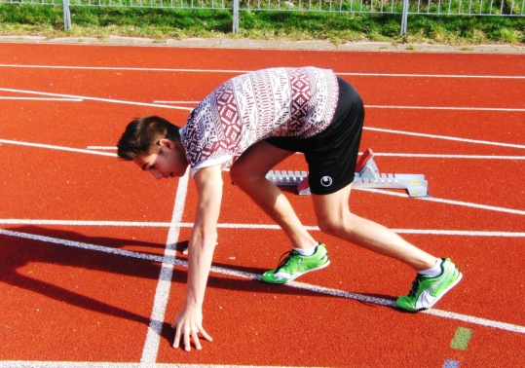
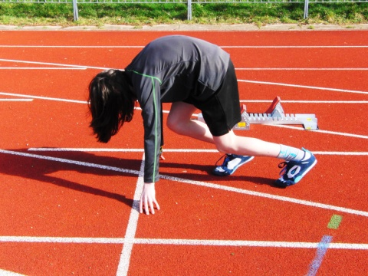
Shoulders too far back Shoulders too far forward Back too bent, hips too low

Having settled that, there is the question of the head position which should be downwards. Looking too far up the track puts strain/stress on the neck and creates tension which detracts from the relaxed position required. Furthermore it can result in the athlete coming upright too soon, which then tends to cause over striding as the athlete tries to get into running before they have finished accelerating, and consequently they have a short period of the leading leg trying to pull rather than push. The answer therefore is to look down, stay low and have gradual phased acceleration.
To recap:
- The hip bone should be ahead of the leading foot when in the blocks.
- The hips will come up higher than the head when in the set position
- The back should be fairly flat
- The head looking down and in alignment with the spine
- The shoulders directly over the hands
COMMON STARTING FAULTS (many were also listed in March 2013 issue)
- Looking up too soon causes the hips to drop as the torso rises
- Over-striding the initial 7 steps
- Having the hips behind the front foot when in the set position
- Leaning the shoulders ahead of the arms puts undue weight on the hands and delays reaction time
- Rear arm not driving back to give ‘equal and opposite’ drive to the leg
- Holding the head up in the set position increases stress/tension in the neck
- Rising to an upright position too soon and not getting enough benefit from the crouch start.
A selection of starting drills
- Reaction drills;- leaping up and running from a variety of positions such as kneeling on the line, lying prone on the back with the head first, feet first, or from a press up position.
- Box drills in which the athlete jumps with two feet, forwards, sideways, backwards, and then runs.
- Single leg box drills are similar except that the athlete is on one leg.
- Triple hops are done in the set position, the legs bouncing off the ground three times before running.
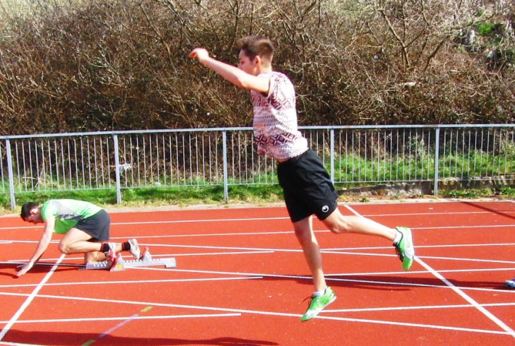
All of the above are fun and yet effectively motivating the CNS to react quickly
Double bound, one leg landing
Using the arms to swing and help propel an upward bound with both legs but only landing on one, leading directly into a run.
Falling Starts
The arms are sideways, hands are held next to the ears ready for a propulsive action. The trailing leg is held up with the thigh parallel to the ground, because this is the first strike in a sprint start.
The athlete falls as far forward as they can before
driving the leg down, and the arms forward and back to begin a sprint for about ten strides, remembering not to apply the brakes too quickly and overload the quads.
Tennis ball kick backs. A ball is placed on the ground behind the hand that is going to react backwards while in a crouch start position, (it is not held in the hand), giving the incentive to apply some force to the arm movement, and as we all know, every action has an equal and opposite reaction. There is also the incentive in a young squad situation, to see who can project it the furthest

Seven stride start target
To encourage concentration on accelerating away from the start.
Using bright yellow tennis balls cut in half, lay out markers starting at 50cm then increasing by 15cm with every stride.eg. 50, 65, 80, 95, 110, 125, 140cm. The athlete then tries to start and hit the markers with each stride. A video camera allows analysis at leisure.

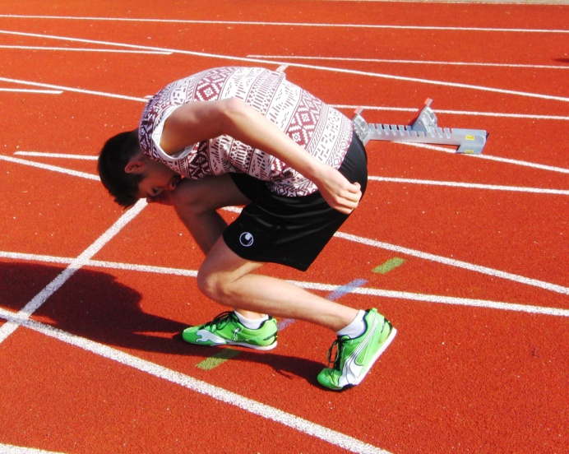
The Curly Cat can be very effective with replicating the drive out of the blocks without actually getting down to a crouch start, and therefore can be done several times fairly quickly.
Start from an upright stance, bending the knees and bringing the head down to the leading knee, putting abnormal bend into the legs, before springing forwards, running to practice keeping low.

Lunge jump runs
The athlete is in the lunge position before jumping vertically three times before running
Scissor jump runs
Also in the lunge position, the athlete spring upwards, scissoring the legs in mid air, and runs on landing.

Some of these drills may sound ‘corny’ but they concentrate the mind, motivate the CNS for quick reactions and give a bit of variety to training

CONTRAST SHOWER – THE POOR MANS ICE BATH!
Hot and cold shower. 2 minutes hot, 1 minute cold x 3, always finish with a cold shower.
I cannot say I have tried it but it is recommended for recovery from a hard workout with sore muscles.

NEXT MONTH The 400m

