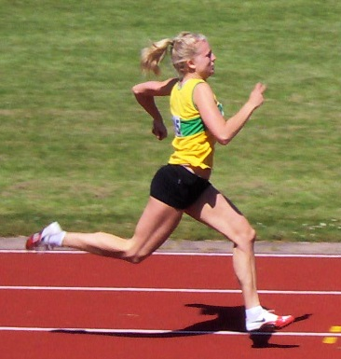

A free e-magazine for speed coaches established in 2006
Available to anyone from tonylett1@gmail.com
UKA Level 4 Development coach for Speed and Physical preparation

ISSUE 88 JUNE 2014
THE FEMALE CYCLE
Over the years I have often question female athletes if their running is affected by their period, and invariably they say ‘no’. But is it, and they just don’t know. So the only way to find out is for them to use this graph (extrapolated from an article in Athletics Weekly, November 2013, and record their performances against a chart indicating their estimated position in the cycle, until they build a picture of performances

 | Fallicular Phase 14+/-3 days | ovation | Luteal Phase 14 days
Possible iron loss from heavy bleeding | Ostrogen rises and helps metabolism for short duration exercises  Progesterone |  | Mid luteal phase better for longer distances.  Ostragen and progesterone  Levels drop if there is no  fertilization  possible loss of electrolytes,  fluids & Dehydration onset  Not the best week  for high output
Menses (period) | Progesterone output remains level but may rise with high intensity exercise | Average 28ays | Progesterone increases, as does body temperature. Not good for prolonged high intensity on hot humid days

Monthly day
performance
Comment

SPEED is the distance covered in relation to a given time, and from a running perspective it is measured in m/sec, pretty much the same as velocity. A 100m sprinter can only maintain the same speed for a very short period of time at a point that will vary according to the standard of the athlete; on average this will occur after about 6-7 seconds

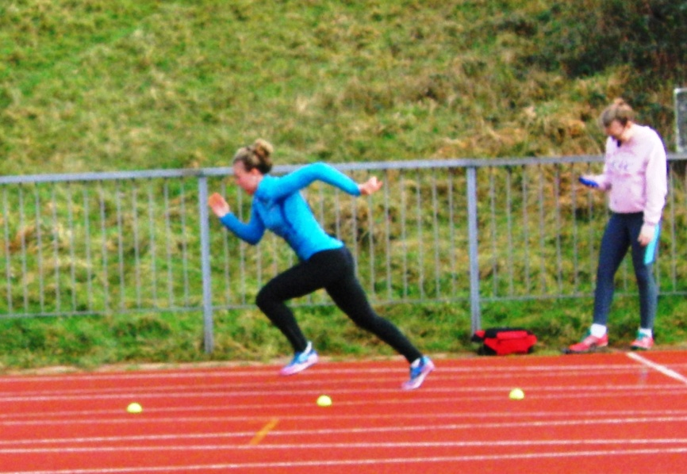
ACCELERATION/DECELERATION
This involves a constantly changing speed, either getting faster or slower, and is therefore measured in m/sec/sec
It is a known fact that speed drops off towards the end of a race, even though it may look as if athletes are maintaining velocity or even getting faster; so in February we did some comparison runs using the club’s recently acquired electronic timing gates, with athletes who only train 2 or 3 times per week
On the assumption that at this standard the athletes would probably be reaching their maximum speed fairly early, we first measured their 10m time between 20m and 30m; then we compared this to their final 10m split at the end of 100m run, the results proved interesting, bearing in mind this was done after at least one hour into the session. On average they were 0.15 seconds slower over the last 10m. Our next aim was to measure them between 30m and 40m to verify their point of reaching max speed.
The first 30m in a 100m race averages 50% of the total race time for international athletes, but this is not so with club level athletes, otherwise, if the 50% rule was applied then the tested athletes are all capable of setting ‘world age best’ performances; which dismisses the theory of direct comparison between Jo Blog and Linford Christie. The fact is; international athletes can keep accelerating up to 60m or more, then attain and hold a higher velocity for 10-15m before decelerating. by about 0.5m/s/s, whereas the club athlete may initially accelerate at a similar rate but will reach his/her maximum velocity much sooner (and therefore a lower speed), and will decelerate faster, by as much as 2m/s/s. How the following energy systems are trained will dictate the period of acceleration, hold and deceleration, and therefore, the end time..
100m
Alactic lactic
200m
Alactic Lactic Aerobic
400m
Alactic Lactic Aerobic

Alactic, Lactic and Aerobic refer to the energy source called upon to perform the demands of the event and are generalized, because it is impossible to be specific about the start and end times across all athletes, and in any case, there is a gradual integration between energy systems..
We can conclude from this that doing more Alactic work will extend the Alactic period threshold (not necessarily making it faster; that will depend upon the training regime), and extending the period of acceleration that should result in an overall better time.. This also applies in the 200m where the lactic phase may well extend into an aerobic phase, and for the 400m the athlete should have an extended, controlled, acceleration period but will not reach the same peak velocity as in the 100m,. and will have an extended aerobic phase.
So, for short sprinters, forget about endurance and concentrate on short, alactic runs, topping up with med ball power throws and quick plyometrics exercises such as bounding without depth, box bound with chest throw, running onto a box with one leg and chest throw as you come off. Max box height of 15-18”
Lactic work will benefit from broken runs such as 40m@100%/40m on hold at 95%/40m @100% It is the time of the year when quality beats quantity, so long recoveries of 15-30 minutes will benefit the end result. Alternatively, running 200/100jog/100m, again, with long recovery for 400m runners, or 150/50/50 for short sprinters.
Lactate ispryvuate acid and hydrogen irons, these ltter causing a tendacy towards breathlessnerss due to the build up of CO₂ which slows down the nerve impulses of the CNS.
When talking in percentages, athletes can relate better to % of best time, rather than effort.
Speed improvement only occurs when running faster than 95%, and anything less than that will only develop endurance and fatigue. Running 30m sprints for example will benefit from 4-5 min recovery, while running slowly in training will result in slow running races, so 75-95% is a no,no. This should be taken into account when planning long recoveries that could be occupied with low stress training such as mobility and stretching. Coming away from a speed session feeling knackered is not a true reflection of gaining speed, the athlete would be better off coming away on a high, knowing they have been training close to their race time

Because we have a mixed group we try to blend them together, with the short sprinters joining in with the 400m runner over the final stretch of ‘own the finish’
In the picture we were using half tennis balls to measure stride length during acceleration, while recording it on a video camera.

STRETCHING PART 2

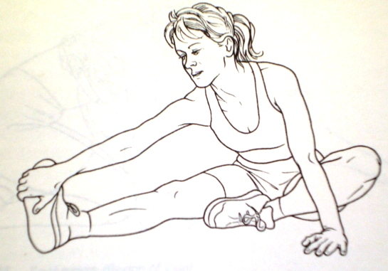
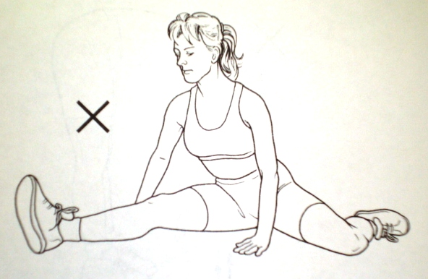
NEXT MONTH:- Hip Flexors

MOUNT TOUBKAL
If you will forgive this diversion from the norm, but because I received donations from several readers I feel I ought to report on the toughest two days of my life, where at the very least, I learnt something about the hamstrings – a subject that I had planned covering in the August issue

There were 11 of us including one woman, me being the eldest at 77, the rest averaging out at the mid thirties, but we formed an instant bond.
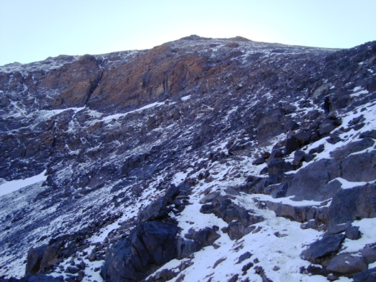
It was 36 degrees C when everybody checked their mobiles for last minute messages before heading for the High Atlas mountains, shimmering on the distant horizon. The mini-bus dropped us in a village at about 2000m up, where pack mules were waiting to carry the heavy baggage while we began the first six hours walk. Initially it was fairly flat, giving a false sense of ease, but soon the boulder strewn path steepened and it was ‘game on’ for the next five hours of a muscle taxing climb. Lunch was under a lean-too on the side of a mountain as we wound our way through the foothills at a mere 6-7000ft, until our destination, Toubkal, came into focus. Towards the end of the day, at 3200m (that is a tad over 10,000ft in old money), the hamstrings began to complain about working overtime as the Refuge hostel came into view, but by the next morning they were fine.
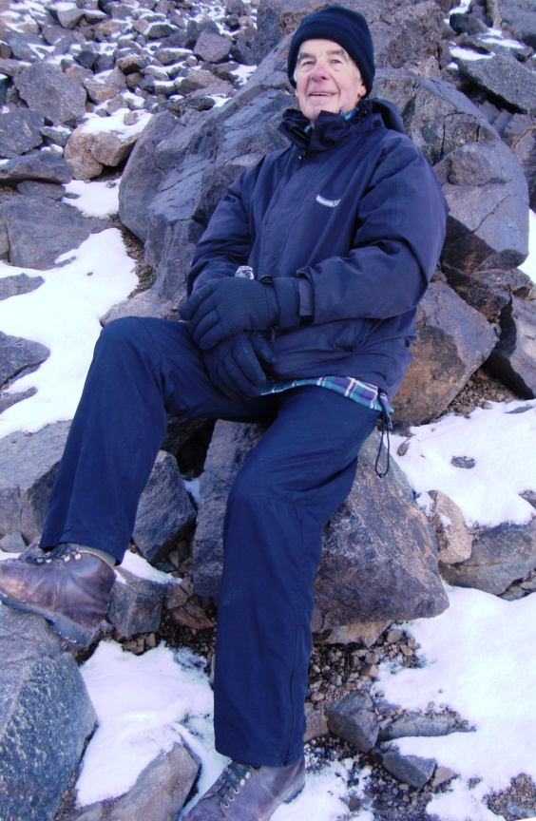
This was a stone building of basic facilities, where we huddled in a common room next to the kitchen, drying out our clothes from the earlier rain, and drinking coffee next to an iron stove. The sleeping quarters were above; accessed by a wooden stair that would give any health and safety inspector a coronary, and it was every man or woman to themselves, sleeping side-by-side on what could loosely be described as communal bunks. My alarm clock was rated the best thing since sliced bread (!), getting us up at 3.50am the next day to begin climbing the final 1000m by torchlight. This was even tougher, with boulders 2-3ft high, ALL THE TIME, hour after hour, so we could forget any thoughts of a recognizable path. Within fifteen minutes we passed through the snow line, climbing and scrambling through the white stuff and melting ice. I slipped several times, and being older than the average climber, was more cautious; but despite this I fell quite badly, 200m from the summit,(see arrow) injuring my right arm which came up like a balloon, bruising from wrist to elbow and severely jarring my shoulder. Fortunately my left arm simply had a six inch bruise. I sat and carried out movement checks as I watched the rest of the party reach the summit in -6⁰ C. There was a cold wind blowing, and despite wearing cold weather gear my fingers were icy from Reynard’s. I wasn’t tired despite my aching limbs; I’m just not young anymore. This was decision time; to go on, wait or descend. Common sense prevailed as I weighed up the consequences of further falls, and considered those expecting me to return in one piece; (a casevac at this altitude would cost a bomb), and so I reluctantly began a slow, careful decent, only falling once more. The others caught me before the Refuge, and the rest is history.
I have no regrets about the decision; my reckless days are over.
We descended for another six hours until 5pm, (meeting two British athletes training for the Mont Blanc marathon) to a hostel sporting beds and hot showers, where nine of the team took off in a single taxi to watch a European soccer game in a village café.
According to a Garmin, we had covered 30km of climbing up or down in two days, so the final day of less than two hours was a cake walk, leaving us free to relax and explore Marrakech at night before flying home the following day. Those who had done Kilimanjaro said that this was tougher, so if you are looking for a challenge, try Exodus; their organization was good but flexible
It is early days to give a full picture of my fund raising activity, but the Beating Bowel Cancer campaign on www.justgiving.com/Tony-Lett was last seen heading towards £500 while the ‘local’ collection from the athletics club, gym, village shop, family and friends looks like it could hit a similar target, and that will go towards funding the new cancer treatment centre at Treliske hospital, which ironically, I may need to use at sometime in the future, but, inshala , the later the better.
So, a big thank you to all of those who donated, and for those who haven’t yet, there is still time

